In a famous 2011 article in Vanity Fair, Joseph Stiglitz, the Nobel Prize-winning economist, first

warned that our economic policies were increasingly dominated by the richest 1 per cent. Then

the Occupy Wall Street movement electrified the concept with political urgency. 1/3

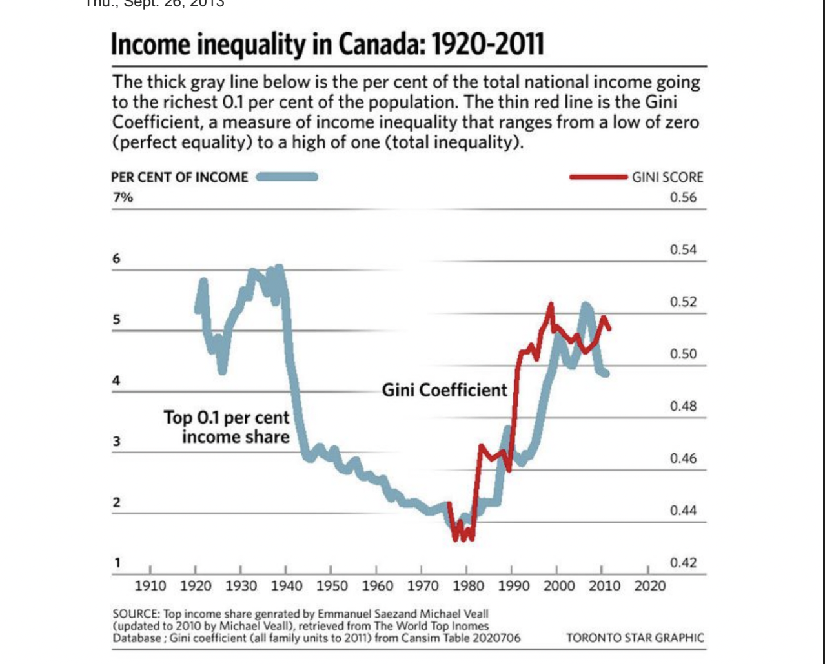

Now Statistics Canada has turned its attention to the problem, too. The agency’s National

Household Survey has documented the stark differences in personal income between the

richest 1 per cent and the rest of us. The data are less precise than would have been attained

from the former long-form census (which was cancelled by the data-phobic Conservative

government). But despite its flaws, the report confirms that the gap between rich and poor in

Canada has become enormous.

Incomes for the bottom 90 per cent of Canadians averaged just $28,000, according to the

report. In contrast, the top 10 per cent took home an average of $135,000. And the top 1 per

cent pocketed $381,000.

Despite data like these, some still argue that income inequality in Canada isn’t an issue

because it isn’t increasing. Others admit that the level of inequality is high, but we should

graciously accept it because it encourages people to pull themselves up by their bootstraps.

Neither argument carries much weight.

The accompanying figure starkly describes the historical trend. The thick gray line indicates the

share of national income going to the richest 0.1 per cent of the population (the richest of the

rich, if you like). The thin red line shows the Gini coefficient: a broader measure of income

inequality, which ranges from a low of zero (perfect equality) to a high of one (total inequality).

By either measure, income inequality has reached a historic extreme. Inequality was high

during the 1920s and 1930s (the “gilded age”), but fell sharply during the Second World War

(as Canadians got back to work and taxes were raised to pay for the war effort). The three

decades after the Second World War — a “golden age” of controlled capitalism — saw further

decline in inequality. The economy was booming and powerful institutions (like progressive

taxation and surging unionization) ensured the wealth was broadly shared.

Since 1980, however, we’ve entered another “gilded age.” Business-friendly economic and

social policies replaced the former Keynesian welfare regime. In recent years, inequality has

reached levels higher than at any time since the 1930s. And it is clearly staying that way,

regardless of small year-to-year fluctuations.

Does income inequality matter? There’s a growing consensus among scientists from many

disciplines that it does: in complex, surprising and economically important ways. Numerous

studies document a powerful relationship between income inequality and varied dimensions of

social pathology.

Indicators as diverse as happiness, mental illness, infant mortality, children’s educational

performance, teenage pregnancy, homicide, imprisonment, social trust and social mobility all

get worse as the income gaps within society deepen.

The reigning economic orthodoxy assumes the distribution of income reflects “market forces”

and “productivity,” but history confirms distribution is actually shaped by the power institutions

of society. In Canada, three core institutions have been especially important: corporate power

⅔ redistributes income upward, while labour unions and governments redistribute income

downward.

Previous research by one of us revealed the historical relationship between corporate power

and the distribution of personal income. It turns out that relative size of the largest firms in

Canada strongly affects the distribution of personal income: the inexorable corporate

concentration in recent decades has clearly produced greater inequality.

This study, “A Shrinking Universe,” also documented the downward redistribution of income

resulting from organized labour. Union density grew steadily from 16 per cent in 1940 to 37 per

cent by 1975, but has declined steadily since then. As union density increased, income

inequality decreased — and vice versa during the new gilded age.

Governments are also downwardly redistributive. The most obvious effect is through the tax

and transfer system (although the progressivity of Canada’s tax system has diminished).

Government spending also redistributes income downward. This is partly because public

sector pay scales are more compressed than the private sector — with a higher floor and a

lower ceiling. As public sector activities form a larger proportion of GDP, inequality moderates.

The retrenchment of the Canadian public sector since 1992 has thus contributed to upward

redistribution.

All of this suggests some obvious conclusions regarding how to reduce inequality: strengthen

the voice of organized labour and amplify the redistributive aspects of the Canadian state. Our

own history proves there is nothing “natural” or “inevitable” about the level and trend of

inequality. The present lopsided balance of institutional power in our economy and society

(with big business increasingly calling the shots) and the resulting skewed distribution of

income reflect past political and economic decisions. We need not replicate those decisions in

the future.

Jordan Brennan and Jim Stanford are economists with Unifor, the new union founded on

Labour Day weekend through the merger of the CAW and the CEP.